Wise like Solomon
These bible studies have been inspired by a present Rev. Ben was given by the Kexborough Girls Brigade at Christmas. There’s a picture below but in case you cannot read it, it says at the top “At GB we are…” and then proceeds to list the titles we’ve been using “thankful like Hannah,” “Faithful like Daniel” and now “Wise like Solomon.” So, let me begin by asking you, do you want to be wise like Solomon?
According to 1 Kings 4:32 Solomon is responsible for 3,000 proverbs and 1005 songs. Verse 33 seems to describe him as a biologist for “He also spoke about plant life… animals and birds, reptiles and fish.” People from all nations were sent by the Kings of all nations to listen to Solomon’s wisdom. Most of us will have heard the story of Solomon and the two mothers who claimed the same child (Read 1 Kings 3:16-28), so do you want the wisdom of Solomon?
Why am I asking you this question, and I think it is because I know the end of the story. At the beginning of chapter 3 (1 Kings) we hear how God appeared to Solomon in a dream and said “Ask for whatever you want me to give you.” Solomon replies by acknowledging the weight of responsibility that has been placed on him by his appointment as King and consequently his father, King David’s death. Solomon declares himself “only a little child” and asks God for a discerning heart to govern God’s people and to distinguish between right and wrong. God responds by saying because you have not asked for wealth, a long life or death for your enemies I shall do as you ask and moreover I will give you that which you have not asked for; wealth and honour.
Questions
- If God told you to ask for whatever you wanted God to give you, what would you ask for?
- Solomon’s answer was to ask for something that would help others, not himself. He wanted to be able to lead a just and fair society do you think it was this seemingly selfless request that led to God’s response or something else?
- In deciding which mother to choose or what to ask of God Solomon seemed to take a step back, to step out of the immediate situation. The wise people I have seen also seem to have been able to do this, does wisdom require certain “out of the box” thinking?
- What situations (boxes) might you need to step out of so as to be able to gain fresh perspective at the moment?
God’s promises to Solomon come true. Israel sees he has been given the power to administer justice and Israel seems to thrive, Solomon builds a palace and the temple is built and furnished under Solomon’s reign. Those people of all nations arrive, and he writes, proverbs and songs, which he could not have done so prolifically had Israel been at war/in danger – his attention would have been needed elsewhere. Gold pours in and nothing in the palace is made from silver because silver was considered of little value in Solomon’s days (1 Kings 10:21).
Still sounds fine and dandy doesn’t it? Except in 1 Kings the narrative of Solomon’s life comes to a rather abrupt end. Chapter 11 is dedicated to Solomon’s downfall and demise. It turns out that whilst he can dispense all this wisdom in ruling the country that perhaps he does not show the same level of wisdom over his personal life. Solomon had a penchant for foreign women, besides pharaohs daughter he had seven hundred wives of royal birth (from the Moabites, Amonites, Edomites, Sidonians and Hittites – people the Israelites were forbidden to intermarry with) and three hundred concubines. These wives led him astray. They had him build alters to their Gods and so Solomon’s heart was not completely devoted to God and a such made God angry. An anger that would ultimately split Israel and cause Rehoboam, Solomon’s son much hardship.
Questions
- Does the end of the story change any wisdom Solomon did show earlier on or in different parts of his life?
- Would you still consider Solomon wise?
- Do you still want to be like Solomon? Why, why not? Perhaps just a bit like him?
- Clearly God held Solomon to very high standards. What standards do we hold ourselves too? And how do we feel/what do we do when we fail to meet them?
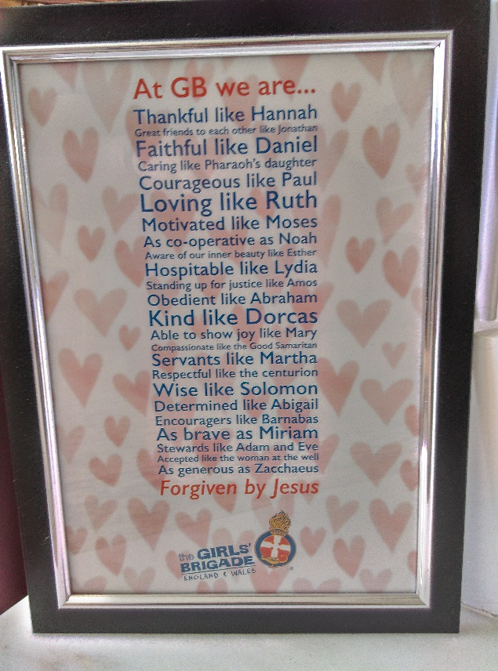
Something to ponder: Many people seem to suffer because they simply cannot live up to the expectations set by the church, other people, or themselves. How do we as a church hold the reality of living in a fallen world with the high standards we often ascribe to God and Jesus?
This has been based on the narrative of Solomon in 1 Kings chapters 1-11 but Solomon is also mentioned in 2 Samuel and 2 Chronicles 1-9 and of course some psalms, proverbs and the song of songs are attributed to him.
“The heart of the wise makes his speech judicious and adds persuasiveness to his lips. Gracious words are like a honeycomb, sweetness to the soul and health to the body.” – Proverbs 16:23-24

